**Course Outcome to be mentioned which is mapped with this lecture topic.**

CO5 :- To perform different operations on videos.

**Reading Material of this lecture topic.**

What is morphing animation?

In animation and movies, morphing is a special effect that converts (or morphs) one image or shape into another with a smooth transition. Traditionally, dissolving processes on film would be used to create such a representation.

[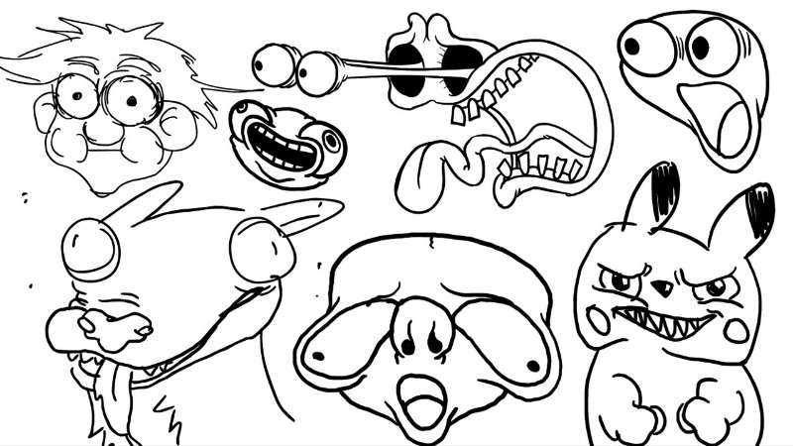](https://animost.com/?attachment_id=89404)

Morphing is a special effect in motion pictures and animations that changes (or morphs) one image or shape into another through a seamless transition. Traditionally such a depiction would be achieved through dissolving techniques on film.

**Types of morphing in animation**

[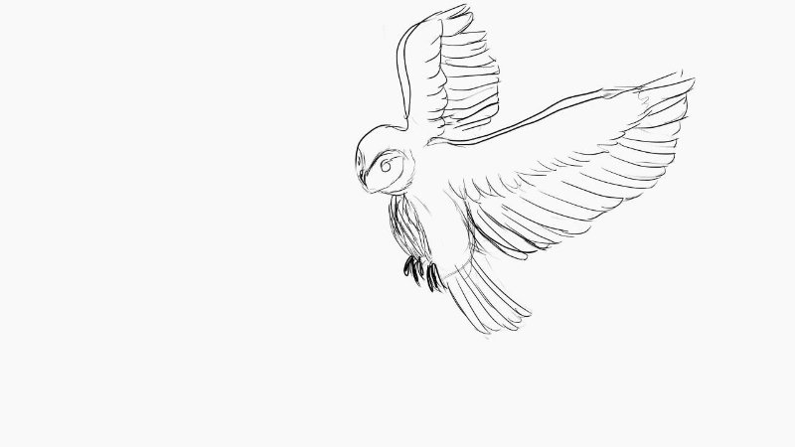](https://animost.com/?attachment_id=89405)

Types of morphing in animation

**Morphing at max speed**

This kind of morphing is frequently seen in movies. Things can change while they’re moving. The spacecraft in Flight of the Navigator is one such. It is simpler to cover up any minor irregularities by morphing moving objects because they are moving quickly and are less likely to be observed.

**Direct morphing**

For simpler animations, morphing is another option. For instance, to change a straightforward line-drawn design into a different shape. To switch from a square to an animated circle in Adobe Animate, use the shape tween tool.

**3D morphing**

Another strategy is 3D morphing. It is a 3D modeling process, not a film industry approach. These morphing animations are employed to change between various motions. A morph target specifies each gesture or posture. It’s employed to give motion to non-skeletal items.

## History of morphing in animation

[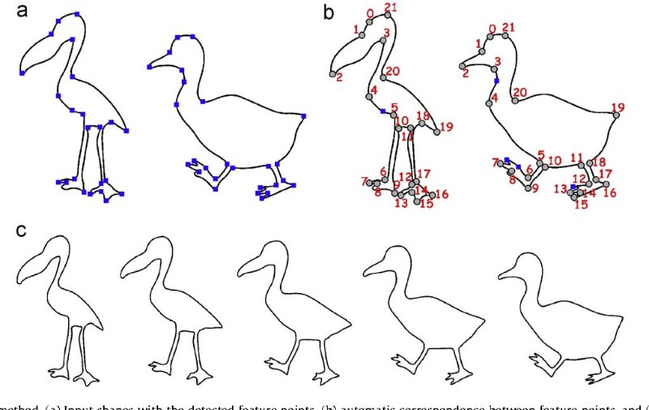](https://animost.com/?attachment_id=89406)

History of morphing in animation

In Hollywood, morphing animation first appeared in the late 1980s and early 1990s. The method evolved as digital technology started to change how movies were made and edited.

Early digital morphing techniques were employed in 1986’s Flight of the Navigator to produce the special effect of a spaceship that transformed from chunky to aerodynamic as it accelerated. A group at Omnibus Computer Animation, comprising Bob Hoffman and Bill Creber, produced this.

In 1989, with its seamless transformation of a goat into an emu, a peacock, a tortoise, a tiger, and finally the human sorceress Fin Raziel, Willow set new standards in visual effects.

One of the most recognizable scenes in the contemporary film was produced in 1991 with the use of morphing for the blockbuster sequel Terminator 2: Judgement Day. The movie’s antagonist, the T-1000, transforms into furniture, objects, and even the ground.

In 1992, an application from Gryphon Software introduces potent visual effects software to the Apple Macintosh home computer. Bringing morphing technology to the general public, the New York Times, the Washington Post, and PC World magazines all published articles about it.

## Examples of morphing in animation

[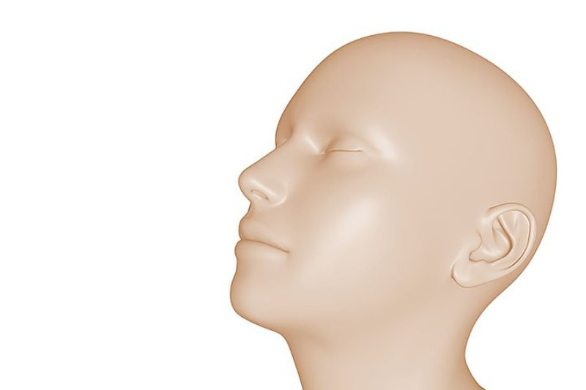](https://animost.com/?attachment_id=89409)Examples of morphing in animation

### **Flight of the Navigator**

A digital effects team used morphing to alter the shape of a spacecraft in flight for this 1986 Disney movie. Jeff Kleiser, an effects specialist, had been experimenting with reflection mapping software and technologies.

He oversaw a group that digitally rearranged the polygons in two spacecraft models so that their topographies were identical. The spacecraft’s appearance changed from clunky to sleek as a result of the seamless transition between these two versions.

### **Terminator 2: Judgement Day.**

James Cameron, the director, transformed what was possible with movie special effects by using morphing. The most famous method used by Cameron in the 1991 movie was morphing.

George Lucas’ innovative visual effects studio, Industrial Light and Magic used morphing technology to depict the T-1000 character’s “liquid” makeup. They constructed computer models to match the many states of the T-1000, from chrome to melting blob, after laser scanning actor Robert Patrick, who played the T-1000. It was the 1992 Visual Effects Oscar winner.

## How does morphing work?

[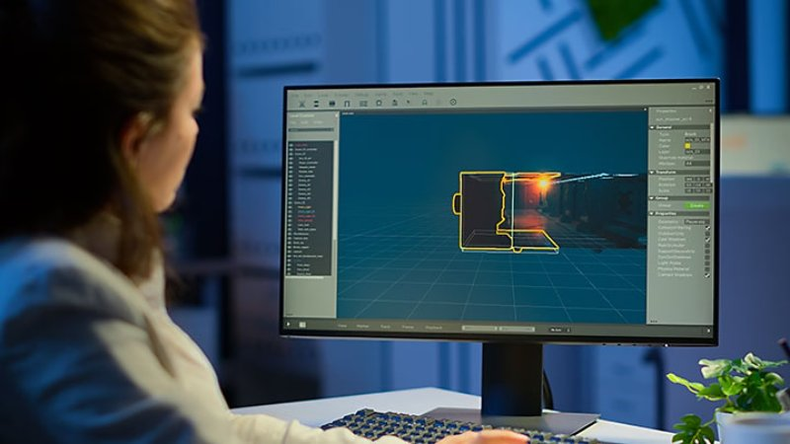](https://animost.com/?attachment_id=89407)How does morphing work?

### **Target and source images**

Each animation morph has a target and a source picture. The original object, such as Robert Patrick’s face in Terminator 2, is the source image, and the new element, whether it be an animal or liquid metal, is what you wish to transmit to it.

### **List the features**

To establish precise measurements, the precise contour of your original source material, such as an actor’s skull, must be mapped. These are then utilized to make models or locate videos of the target of the morph.

### **Aligned feature points**

A succession of points in both the original and morphed objects will be recognized by specialized software. This makes sure that important regions, like an individual’s eye, match. In-between frames then swap the pixels from the old object for the new one after these places have been corrected.

## How to do morphing in After Effects

[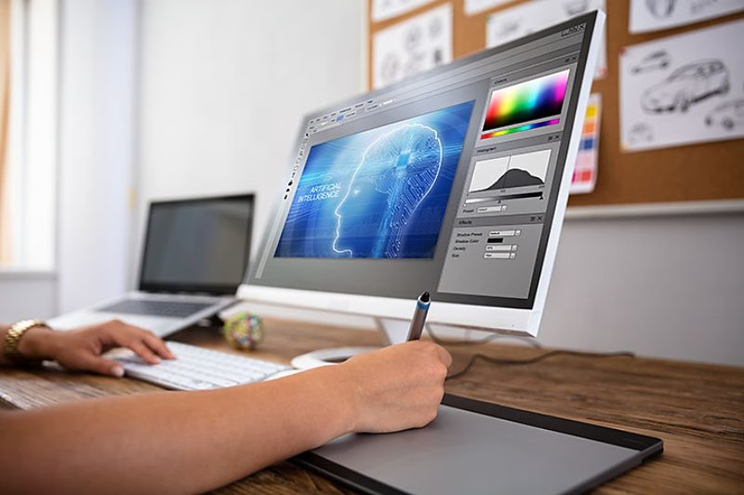](https://animost.com/?attachment_id=89408)How to do morphing in After Effects

***Step 1. Split the layers***

Have the original object (let’s say a smartphone) and the one you wish to morph into it in a clip first (say, a cushion). Then, create two layers for this clip, one for each object. Just divide the layer into two copies.

***Step 2. Trim the clips***

There are now two clips available, one for each object. Now, you must precisely trim each of these to the point where the morph transition will occur. To make sure that movements between the two layers are seamless, you might need to conduct some altering.

***Step 3. Mask the objects***

The morphing between the two shapes can now be set up. Draw a mask around the smartphone using the pen tool; if there is movement, you must also animate it. Give the mask a new name, such as “mask phone.” Apply the same procedure to the cushion. For the mask route, enable keyframes.

***Step 4. Add the morph effect***

Return to the beginning of the transition, choose “object two masks,” and paste it onto the layer for object one. Two masks on this layer should now be visible in the mask setting. Then, change the cushion’s mask mode to “none.” Select the phone, and then paste it onto the cushion morph layer.

***Step 5. Set source and destination masks***

Use the “reshape effect” in the tools panel to reshape the smartphone into the shape of the cushion. Set the cushion’s shape as the destination mask and the remote mask as the source mask.

***Step 6. Transition the objects***

The smartphone mask’s contents will then be reshaped utilizing correspondence points into the cushion mask’s shape. These determine which portion of one thing will be molded to the remainder. This is more accurate in After Effects with more correspondence points.

***Step 7. Make it invisible***

The smartphone has now undergone a transformation that gives it the appearance of a cushion. You now fade away the smartphone using After Effects tools, causing it to vanish as it takes the form of a cushion. Repeat steps 5 through 7 for the cushion now.

***Step 8. Play the transition***

On playback, the smartphone will now take on the appearance of a cushion. To make the transition between the two items more seamless, you’ll need to play about with the liquified effect and adjust the opacity.

[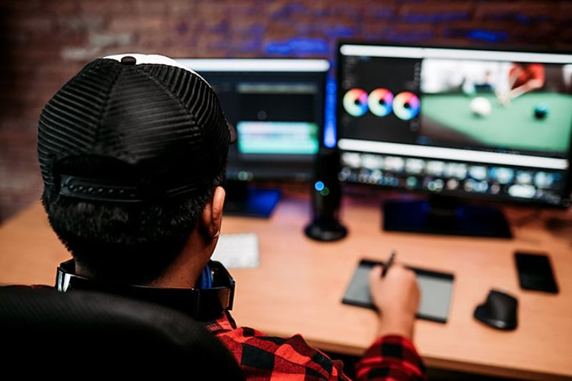](https://animost.com/?attachment_id=89410)Morphing in Animation: Detailed Explain and Guide